

|  |  |
| --- | --- |
| |  | | --- | |  | |

**Executive Summary**

In this report, we are going to design a workflow system for master’s admission in the United Arab Emirates University. Workflow means progress of steps that contain the work process. The system will help in managing the process of admission for applicants. This process will pass from student to admission office then to the colleges. At each step of the workflow, there is a person or group of people who are responsible for tasks. After each task is completed, the system will execute the next task of the workflow automatically. This paperless system will help much in improving the productivity, reducing the time and facilitating the process for both students and the faculty so; they can easily monitor the workflow.

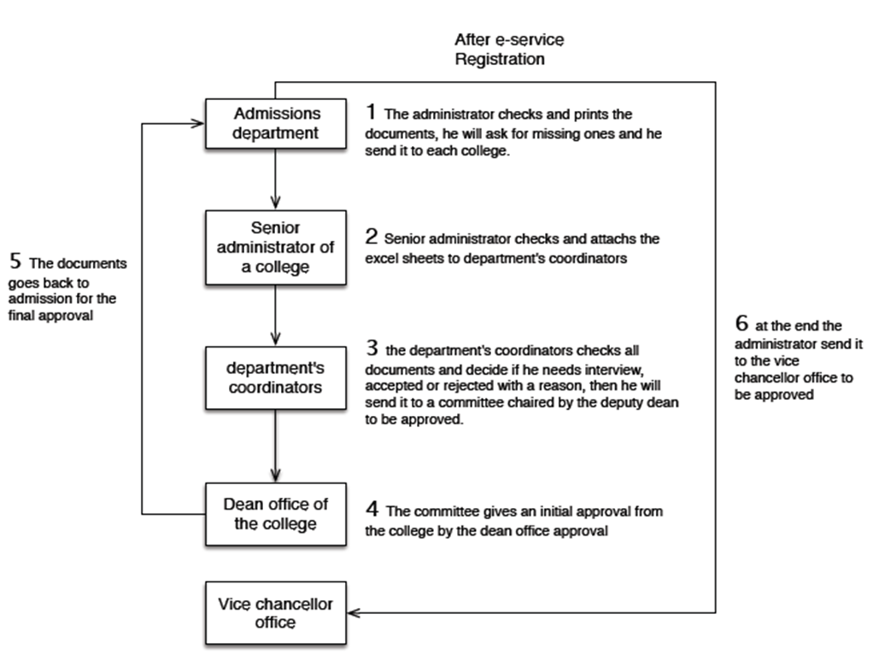 The steps of admission as shown in Figure [0] are: The applicant registers in e-service. If the applicant is new in the university then he has to create an account then login by entering his username and password. After that, he fills in the form and attaches the required papers. . After that, a communication between the admission office and the applicant is done to match the attachments with original ones. Then if the student meets the conditions (GPA over 3 and IELTS equal or above 6), the admission office will send registration request and all attachments to the College. After that, the senior administrator checks and attaches excel sheets to department’s coordinators. Then the department’s coordinators checks all documents and decide if the applicant needs interview, accepted or rejected with reasons, then he will send to a committee chaired by the deputy dean to be approved. Later the committee gives an initial approval from the college by the dean office approval. After that the documents goes back to admission for the final approval. Finally, the administrator sends it to the vice chancellor office to be approved.

**Figure [0]: Process of Admission**

To implement this workflow system, we have to analyze the requirements and designed the database, which we are going to implement it in senior project 2.

Students from different majors will control this project: Software Development, Networking, Information Security and Computer System Design. Our major goal in this project is applying what has been learned in the previous studied years in the college on our practical life and use the technology to facilities our life. We hope this project be deployed in the hall whole university in the next years.

**Table of Contents**

**1** **Introduction**

**2** **Motivation**

**3** **Project Overview**

**4** **Project Plan**

**5** **Requirement Specifications**

**6** **Proposed Solution/Design**

**7** **Implementation**

**8** **Testing Plan**

**9** **Conclusions**

**10** **References**

**11Biography**

**12Appendix**

**List of Tables**

**1** **Table.1 – Class Diagram**

**2** **Table.2 – Test Cases**

**List of Figures**

**1** **Fig.1 – Sequential Workflow**

**2** **Fig.2 – Parallel Workflow**

**3** **Fig.3 – Schedule**

**4** **Fig.4 – Gantt Chart**

**5** **Fig.5 – Project WBS**

**6** **Fig.6 – Add new course from scratch**

**7** **Fig.7 –Add new course by coping**

**8** **Fig.8 –Use Case Diagram**

**9** **Fig.9 –Class Diagram**

**10** **Fig.10 –ERD**

# Introduction

Nowadays UAEU become one of the best universities in the Middle East. To keep its position or get a higher one, UAEU has to meet the requirement of this era of speed and always keeps track of new requirements using the best techniques. Recently the university provides master degrees. We noticed that there is no efficient system for master’s admission in university. Keeping track of registered student status is inefficient. The best solution is designing a workflow management system for master’s admission.

In General Workflow can be characterized as: comprise of arrangement of movement steps (undertakings, occasions and associations) that make up a work procedure which increase the value of the association's exercises. [1]

The Workflow Management System can be defined as a piece of software that provides an infrastructure to set up, execute, and monitor workflows. [2]

For example: In the UAEU admitting master student passes from student to admission department then to senior administrator of the college then to department’s coordinators after that to the dean office of the college and finally to the vice chancellor office. In each stage of workflow, every individual is responsible for his or her specific task and jobs. After the task is completed, the workflow management system will make sure that people that in charge of the task are notified. This system helps in eliminating redundancy of jobs. It is a dependency system, which means you may not jump to next task until the completion of previous task. The functions that used in workflow management system are paperless.

**Classification of Workflow Management System:**

There are three types of WMS: production workflow, ad hoc workflow and administrative systems.

1. Production workflow: predefined job, tasks to be process or need additional steps.

* Example: Claim of car accidents involve basic steps, which are identifying the parties involved, log the police report and confirm with the agent of policy coverage. In addition, it needs additional steps: handling bodily injury, compensate of property and repairing of the car.
* Production workflow dedicates the process and maintains the productivity.

1. Ad workflows: through discussions and created new thing for each workflow. Ad workflows always use e-mail to carry out the work.

* Example: In groupware, everyone need to collaborate to create or work on new design on a new product

1. Administrative workflow: combination of ad hoc and production workflows, which means that the flow is, pre-defined (e.g. approval of expense report) and they will use e-mail to communicate with others.

* Example: travel claims
* This workflow is normally used by administration. [3]
* The type of workflow we are doing in this report is an administrative workflow.

**Types of workflows:**

There are two types of workflows: sequential and parallel workflow.

1. Sequential workflow: the execution of steps is dependent on occurrence of the previous step (one followed by another). For example Figure [1].

|  |  |  |
| --- | --- | --- |
|  |  |  |
|  |  |  |
|  |  | **Figure [1]: Sequential Workflow** |

1. Parallel workflow: two or more steps can occur concurrently. This workflow usually complex and may return to previous tasks if required. It is also called state machine workflow. For example: Figure

**Figure[2]: Parallel Workflow**

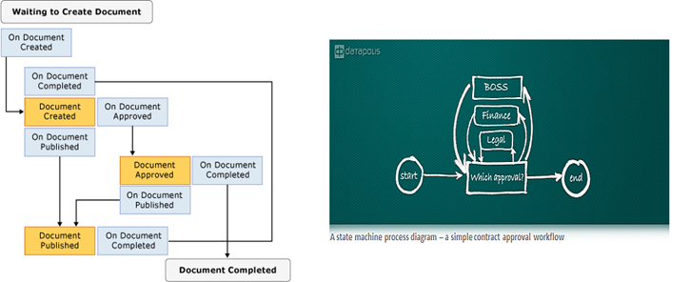

**Advantages of Workflow Management System**

1. Improve productivity: workflow management system helps the organization to improve their productivity.

* Example:
* Without WMS: Approving the client’s changes on their details on paper works. This is leading to waste lot of manpower, times, resources and money. In addition, it will lead to slowness the performance of the organization.
* With WMS: everything can do on split of eyes. When there are changes of the details, staffs can send emails to their supervisor to approve the changes rather than paperwork.

1. Visibility: It is important for the manager to have visibility on the business workflow and understand the whole workflow of department. If anything wrong happen in the business critical process, the manager will identify it and take the appropriate action to fix it.

* Example: In a shipment department, there are many wrong shipments to destination. Manager may easily have identified which flows are causes the mistakes.

1. Change of business reaction is faster: In any organization, the business process may need change to react with market changes so, WMS allows top management in the organization to do the changes fast through modification on workflow system.

* Example: Customers sometimes do abnormal transaction using the credit card so; operator of Credit Card Company calls the owner of the card to get sure from validation of the transaction.

1. Accountability: Helping managers in improving accountably skills. Managers will be familiar with the process so; he can easily allocate resources. This will lead to reduce wasting of resources and focusing on major process.

* Example: A Manager identify administration department and he notice that this department need lesser employees than accounting department so, he can switch some employees to the accounting department. That will lead to improve productivity instead of wasting resources. [3]

# Motivation

We are so proud to be a part of UAEU, this University gave us so much so we as IT students thought to do something that will be helpful for the facility and the students too! Dr. Mamoun told us that the Master Application doesn’t really have an electronic workflow so we decided to do it! It will save the applicant’s time, and the facility too. Ms. Mariam Al Manthari (The Senior Administrative in CIT) mentioned “It will help the college to respond to the applicants easily, and it will help the applicants to know their application status. Also will give the employee less effort and time instead of replying to emails from the applicants or answering the telephone call“. She encouraged us and we saw that it will really help her which made us be certain that we made the right choice! Also, we as students noticed the benefit of the workflow in the advising process, and the attendance system it made the processes much easier for us, we knew were our application stopped, is it got rejected or accepted by just several clicks! So, we thought why not? It will also help us later on, if we wanted to apply for master after we graduate Insha'Allah.

**Project Overview**

Our project will focus on creating a system for master’s registration in College of Information Technology so that will lead to save a lot of time and effort for both college and applicants. The workflow will improve the process of submitting an application for completing the graduate studies and following up with the application status.

Logging in to the system will be according to your position that’s mean you will login as an Admission or Senior Administrator or Student. The good thing about our system from applicant view: the system will show to the applicant where exactly the request reached and from and from admission view: he can easily sees the names of the applicants and sends them emails if anything is missed. The communication between applications and admission can be done easily through email just by clicking the provided icon of email so, no need for searching the email address. In this report we are going to present a use case diagram, a prototype of the system which will show the interface of the functions that will be used in the system and ERD which include all attributes, entities and relations

* **Related Work:**
* **Background: History of Workflow**

In 1980 ago, the structure organization of companies was on crisis and obstacle because it was inflexible and slow to respond to the requirements of markets and customers. With the passage of time the markets became international and that’s led to violent competition between organizations to meet the new requirements by changing the structure which was paper-based task.

In early 1990 organizations have created and developed a new information communication technology that match the new requirement of markets. This new technology is called workflow which was a leading to the new trend of computer industry.

At the end of 1990s, the workflow management system was created with additional function like modelling tools, business rules process and others.

In 2005, windows workflow foundation was created by Microsoft which replaces the original workflow with others functionality like BPM (Business Process Management).[3]

* **Examples of Workflow: CurriCuNET:**

CurriCuNET is a workflow management system which is used by many universities and colleges around the world. In 2002 CurriCuNET has taken the Technology Focus Award from the California Community Colleges Chancellor's Office. UAEU is one of the universities that used CurriCuNET WMS. This software is designed to simplify process and reduce paper handling which saves thousands of annual hours. CurricUNET has been developed to automate the entire process of submitting course and program proposals via a Web browser. It is especially effective for multi-campus institutions that want a paperless solution for this cumbersome process. [4]

* **Adding New course:**

For creating a new course, you can choose between two choices:

You can add new course by two ways:

1. Creating new one from scratch
2. Copying from an existing course and apply the changes.

* For creating new one from scratch:
* Go to ‘Create’ section in the main menu and click on ‘Courses’.
* That will take you to ‘My Courses’ which will display the courses in the system.
* Click on ‘Create Text’ that will take you to screen where you have to enter the information of the course then continue the necessary steps for creating a new course.

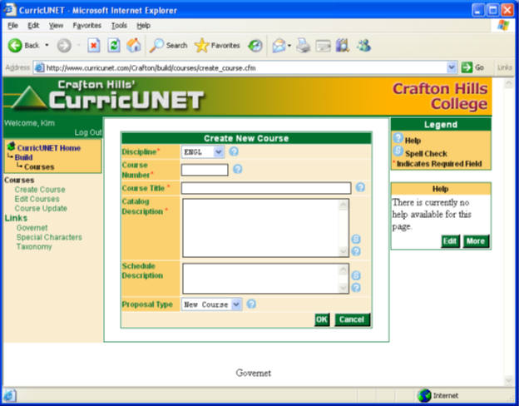

**Figure [3]:Add new course from scratch**

* For copying from an existing course and apply the changes:
* Click on ‘Course text’ and search for the course you want to copy from it.
* The result of search will be shown as a list.
* At the left of course information you will find three icons.
* This icon is for creating a PDF document of the course.
* This icon will take you you to the ‘Course Construction’ where you can edit the course.
* This icon is for copying most of the existing course for modification and add a new course.
* If you click this icon, it will take you to ‘New Course’ screen where you can do changes and then continue on to the ‘Create Course’ to complete the steps for creating a new course .[5]

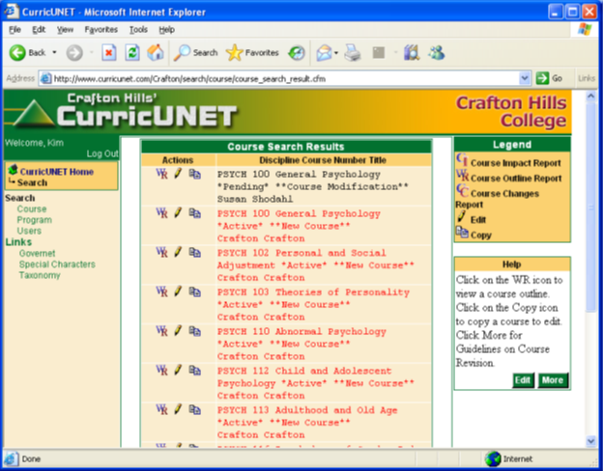

**Figure [4]: Add new course by coping**

**Table [1]: Plan table**

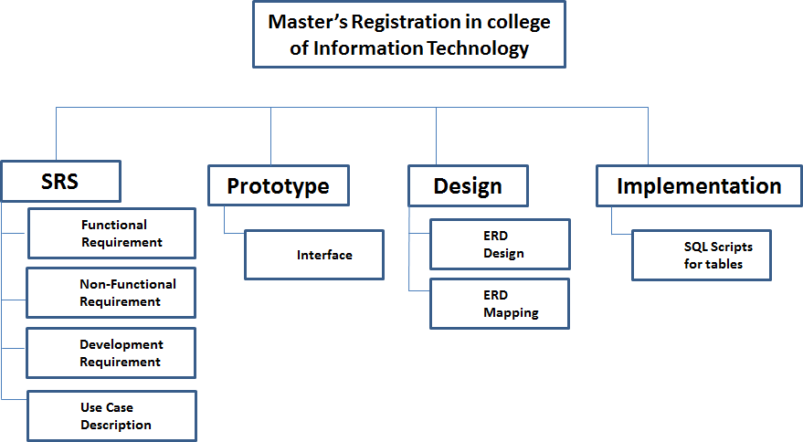

**Figure[5]: Project WBS**

# Requirement Specifications

● **Functional requirement**

1. Returning User shall be able to login
2. New applicant user shall be able to register
3. Login ID composed of 9-digit string
4. PIN is a 6-digit string
5. Applicant user shall select an admission term from a menu
6. Applicant user shall select a provided degree program from a menu.
7. Applicant user shall provide his personal information:
   1. First Name, Middle Name and Last Name.
   2. Indicates a citizen of UAE:
      1. Children of national mother
      2. Citizen
      3. Employee of national mother
      4. Non-Citizen
   3. Email and verification of an e-mail address
   4. Selects a gender either Male or female.
   5. Indicates a marital Status:
      1. Single
      2. Married
      3. Divorced
      4. Widowed
      5. Separated
      6. Unknown
   6. Birth date (MM, DD, YYYY)
8. Applicant user shall provide his International Information by selecting:
   1. Citizenship Country
   2. Birth Country
9. Applicant user shall indicate his mailing address:
   1. Street line 1:
   2. Street line 2:
   3. Street line 3:
   4. Selects Country:
   5. Selects State:
   6. City:
   7. Zip / Postal Code (Enter ( - ) if don't have Zip)
   8. Phone Number (xxxxxx)-(xxxxxxxxxxxx) (xxxxxxxxxx extension):
10. Applicant user shall provide his academic history:
    1. College Name
    2. City
    3. Selects country
    4. GPA (example: 3.89)
    5. Select college Degree, if not found he has to enter it
    6. College Degree Date:
    7. Select Major, if not found he has to enter it
11. Applicant user shall provide his academic interest by writing:
    1. a personal statement (500 words or less) of his research interest and his objectives in pursuing PHD studies at UAEU and the knowledge, Skills, and experiences he believe will allow him to succeed.
    2. outline an area of research in business that he might wish to pursue.
12. Applicant user shall provide his test scores up to 4 with date taken (MM, YYYY):
    1. TOFEL(IBT)
    2. TOFEI(INT)
    3. GMAT
    4. GRE
    5. IELTS in this format (x.x)
13. Applicant user shall provide supporting documents in (.pdf or .jpg) format only:
    1. College transcript
    2. Curriculum vita
    3. Evidence of TOFEL or IELTS
    4. Passport Copy
    5. Photographs
    6. Reference Letter up to 3
14. Applicant user shall be able to click on application complete to submit the application
15. Applicant user shall be able to click on Finish later to be saved in the system database to continue later.
16. Applicant user can check the application status
17. the system shall provide a several statuses depend on a particular situation:
    1. Your application is Pending waiting for approval
       1. Admission
       2. Coordinator
       3. Collage
       4. Dean
       5. Vice Chancellor
18. Applicant user can write a comment and alerted by it.
19. Applicant user can upload the missing files or the updated once.
20. employee users shall be able to select the college
21. employee users shall be able to select an applicant
22. employee users shall be able to check the application and documents
23. employee users shall be able to choose a statue either:
    1. Approved
    2. Rejected with a comment including the reason of rejection
    3. Not complete: assign meeting or missing documents
24. employee users shall be able to write a comment and and alerted by it.
25. Use-Case.pdfUsers shall be able to logout from the system

See Appendix (2).

**Figure[8]:Use Case Diag**

# Proposed Solution/Design

## Class Diagram and the description of each class

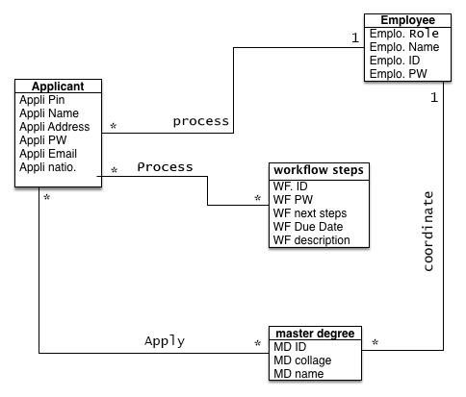

**Figure[9]:Class Diagram**

|  |  |
| --- | --- |
| Class Name | Description |
| Applicant | 1)Applicant class has six attributes (Pin, Name, Address, password, Email and nationality)  2) Applicant class is associated with Employee , workflow steps and master degree classes |
| Employee | 1)Employee class has four attributes (Role, Name, ID and password)  2) Employee class associated with Applicant and Master degree classes). |
| Master degree | 1. Master degree has three attributes (ID, collage and name) 2. Master degree associated with Applicant and Employee classes |
| workflow steps | 1. workflow steps have five attributes (ID, Password, next steps, Due Date and description). 2. workflow steps associated with Applicant class. |

**Table[2]:table of the Class Diagram**

## Human interface - User interface design:

See Appendix (1).

## Data Architecture:

Here we have four different entities

* Employee: which can be either an admissions employee, or a senior administrative.
* Applicant: student
* Master degree: the degree that the student is applying for.
* Workflow steps: the multiple steps of the workflow.

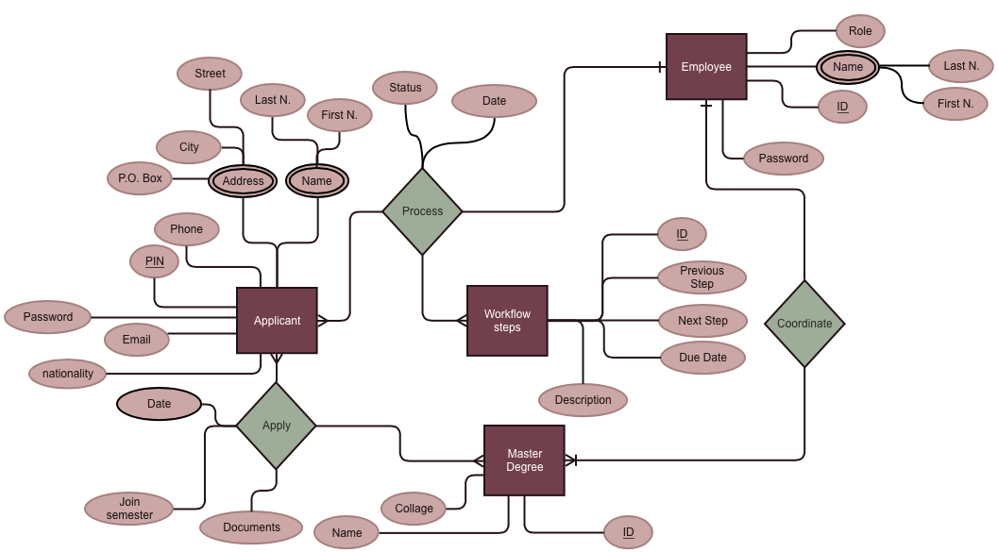The applicant applies for a master degree, which the employee has to process several steps “workflow steps” in order to approve/decline the application “master degree”.

**Figure[10]:ERD**

# Testing Plan

* **Test cases:**

Black box testing will be our method to test our system. Below are some test cases:

|  |  |  |
| --- | --- | --- |
| **Use Case** | **Pre-condition** | **Test Case** |
| Register | System should be up and running. | Input: The user should click on “Register”.  Expected Output:Go to the chosen registration’s page. |
| Next | System should be up and running. | * Case 1:   Input:User clicked on “next” after only filling all the fields.  Expected Output:The user should be taken to the next page.   * Case 2:   Input:User clicked on “next” after filling some of the fields.  Expected Output:Message displayed "please enter all the required fields". |
| Back | System should be up and running. | Input: The user should click on “Back”.  Expected Output:Go to the previous page. |
| Finish later | System should be up and running. | Input: The user should click on “Finish later”.  Expected Output:Go to the previous page. |
| Login | System should be up and running. | * Case 1:   Input:Valid username and password.  Expected Output: The user should be logged-in.   * Case 2:   Input:Invalid username or password.  Expected Output:Message displayed "You entered an invalid username or password". |
| Choose semester | User should’ve been logged in. | * Case 1:   Input: The user chose a semester from the dropdown list.  Expected Output:   * Go to the chosen semester’s page. * List of applicants displayed. * Case 2:   Input: Null!  Expected Output:Message displayed " Please choose a semester in order to display names of the applicants". |
| Choose an applicant | User should’ve been logged in. | * Case 1:   Input:The user chose an applicant from the dropdown list.  Expected Output:   * Go to the chosen applicant’s page. * User should be able to choose approved/rejected. * Case 2:   Input:Null!  Expected Output:Message displayed " Please choose an applicant in order to edit the status ". |
| Check Status | User should’ve been logged in. | Input: User click on the link.  Expected Output:   * Go to status page. * Status displayed. |
| Check comments | User should’ve been logged in. | Input: User click on the link.  Expected Output:   * Go to comments page. * Comments are displayed. |
| Reply | User should’ve received a comment. | Input:User click on the link.  Expected Output:   * Reply’s window appears. * User should be able to write a message. |
| Comment Alert | User should’ve received a comment. | Input:User click on the link.  Expected Output:User logged out successfully. |
| Upload | User should’ve been logged in. | * Case 1:   Input:Uploading a file that does not exist.  Expected Output:Message displayed " File does not exists, please choose another one ".   * Case 2:   Input:Uploading an invalid file.  Expected Output:Message displayed " The file you attached is not valid".   * Case 3:   Input:Uploading an existing and valid file.  Expected Output:File should be uploaded and ready to be sent. |
| Logout | User should’ve been logged in. | Input:User click on the link.  Expected Output:User logged out successfully. |

**Table [3]: black box testing**

**integration testing:**

is the part of software testing wherein individual software modules are tested and combined as a group , the integration testing is happens after unit testing . each member will do part of the system so we need to integrate , We will apply integration testing and compare different part of team member.

**program review:**

A program review will help in planning and evaluating ,its also help to assign the goals , missions and strategic directions , each team member will check other code.

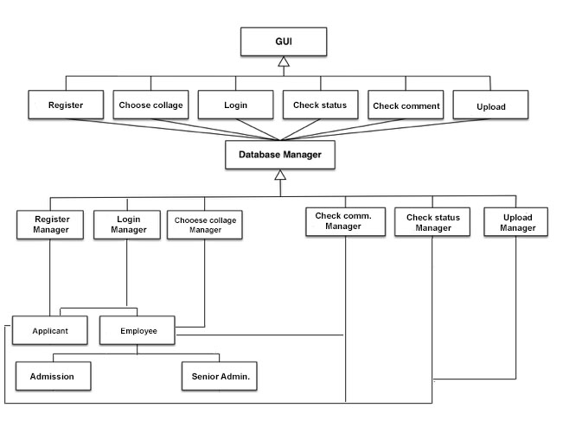**Figure [11]: Database and GUI class diagram**

(Figure 11) is a class diagram for the database and the GUI of our system. Our system will include a GUI with different pages which will connect to the database manager that will be responsible to assign the jobs to the appropriate manger.

For Example : if a user login the database manager will be responsible of it.

**Conclusions**

In conclusion, this report showed you a workflow of Master’s Registration in UAEU which provided an organized process for registration for applicants, admissions, and the senior admin which surely saves the time. In this report we have shown the the system’s functionalities, use case diagrams, designed an interface for the system, and an ER diagram. The workflow system shows all the needed steps for registration (previous steps, current steps and next steps). We expect that this system will save a lot of the time and efforts, and facilitate the process for both students and the faculty so; they can easily monitor the workflow.

# References

[1] “Workflow”, (n.d) [Online]. Available: http://www.businessdictionary.com [Accessed: Oct. 18, 2015].

[2] “Why use workflows?”, (n.d) [Online]. Available: http://www.taverna.org.uk [Accessed: Oct. 18, 2015].

[3]”Studying the history of workflow management systems information technology” (n.d) [Online]. Available: http://www.ukessays.com [Accessed: Oct. 18, 2015].

[4]”CurricUNET”, (n.d) [Online]. Available: [http://www.curricunet.com](http://www.curricunet.com/cnet_home/modules.cfm) [Accessed: Oct. 18, 2015].

[5] ] “CurricUNET User's Guide “

# Appendix 1: User Interface

Registering (for applicants)

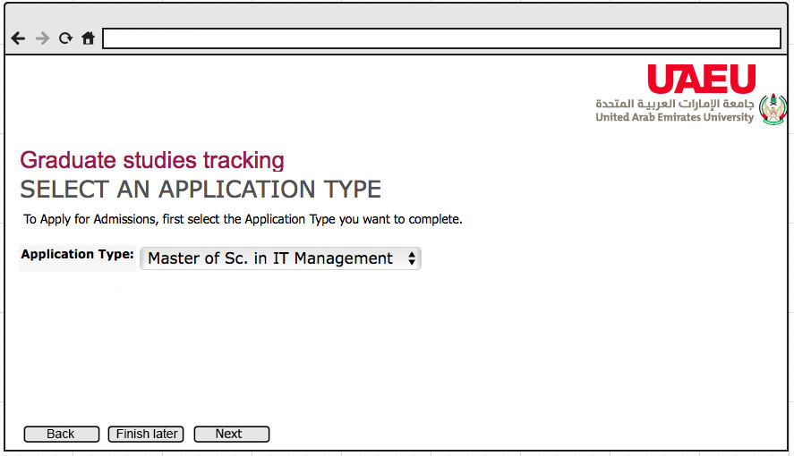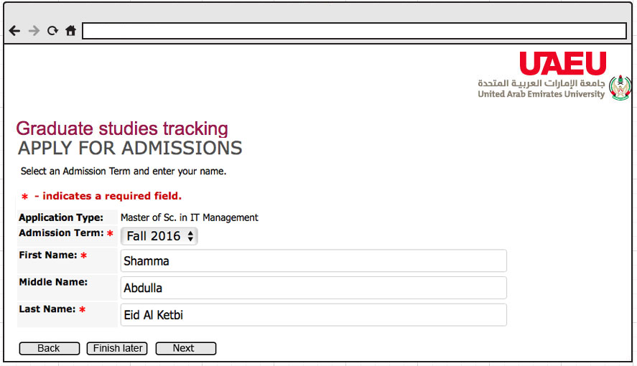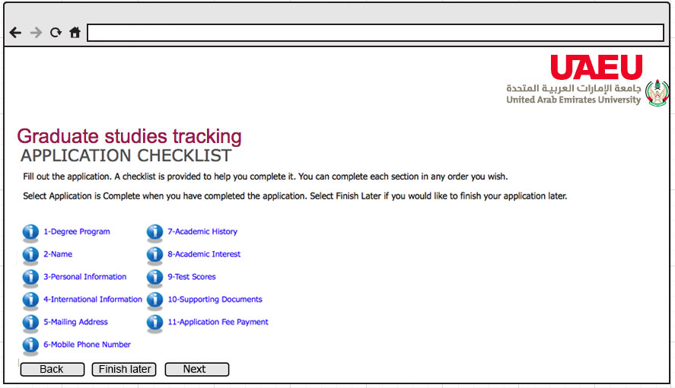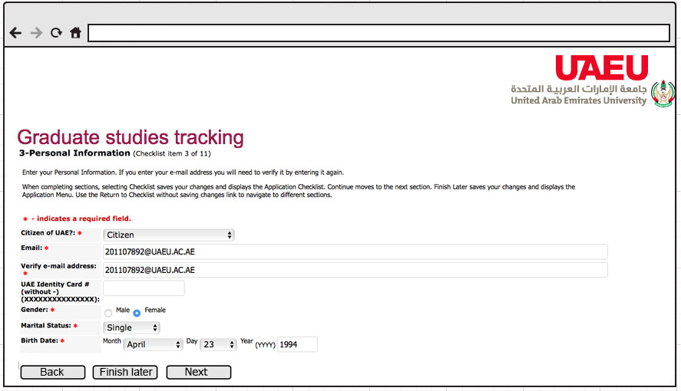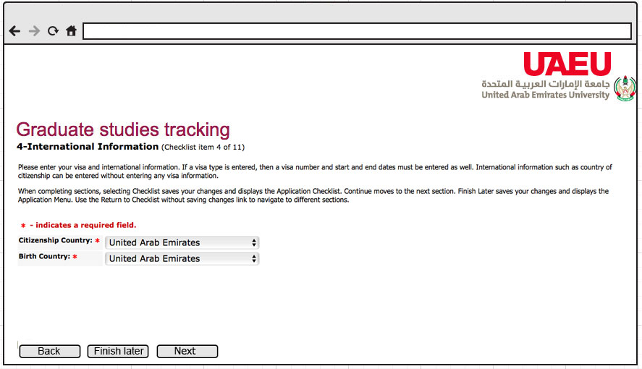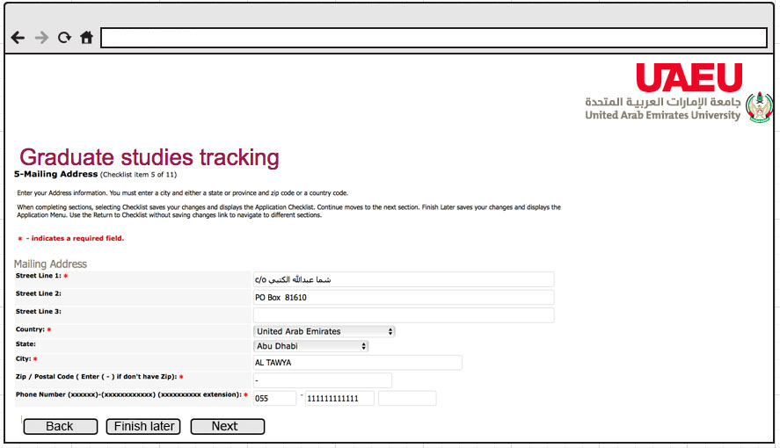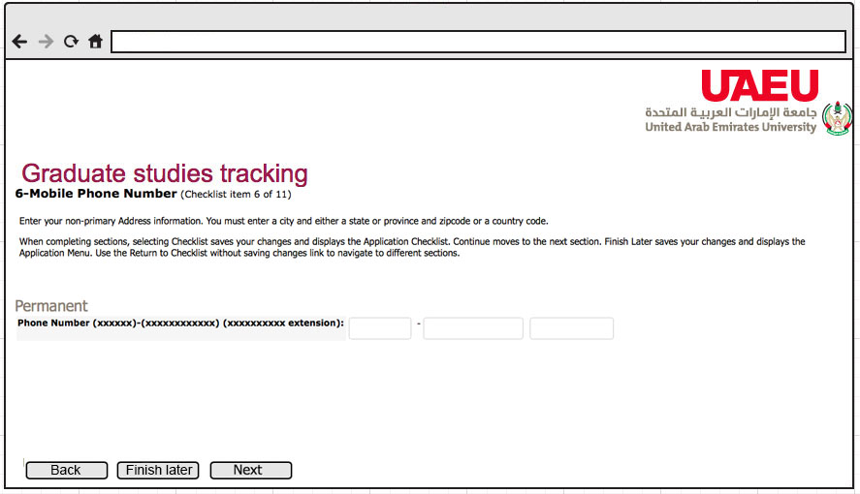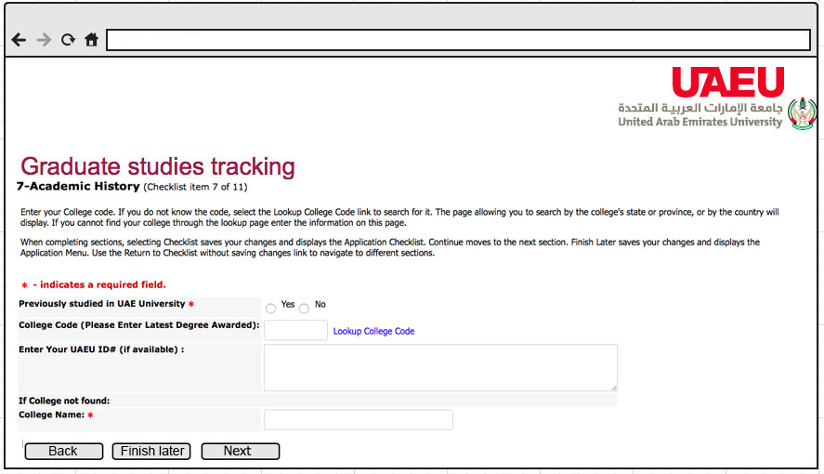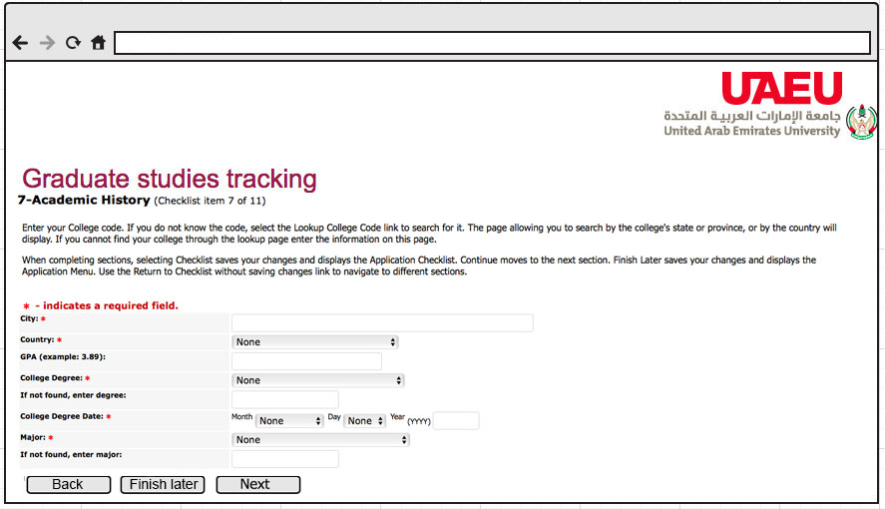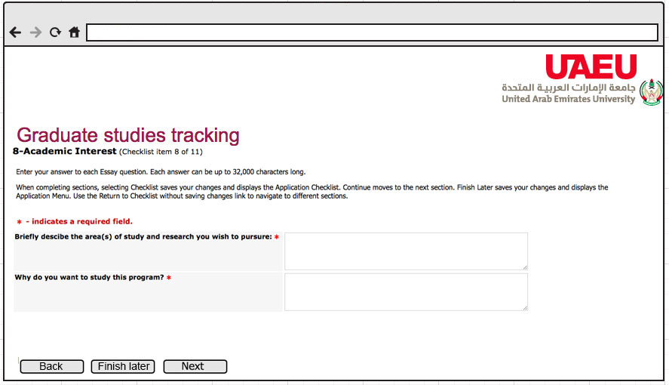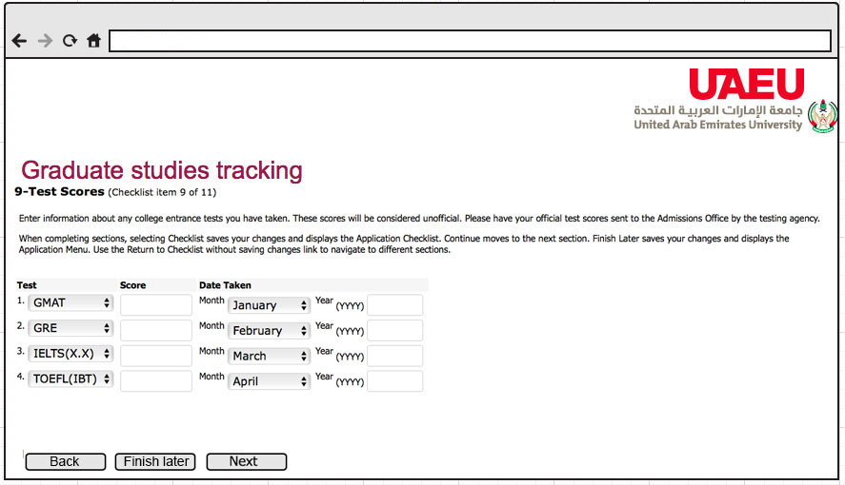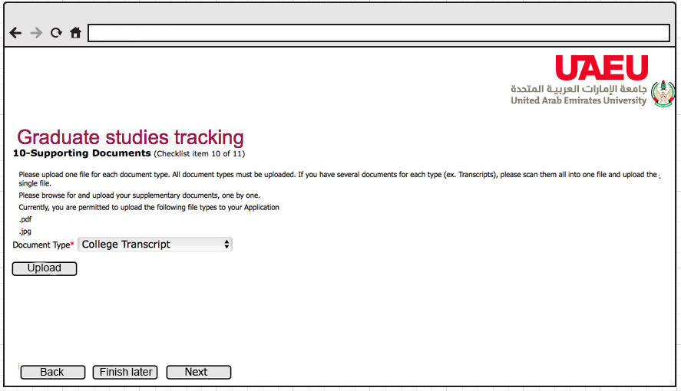

Login:

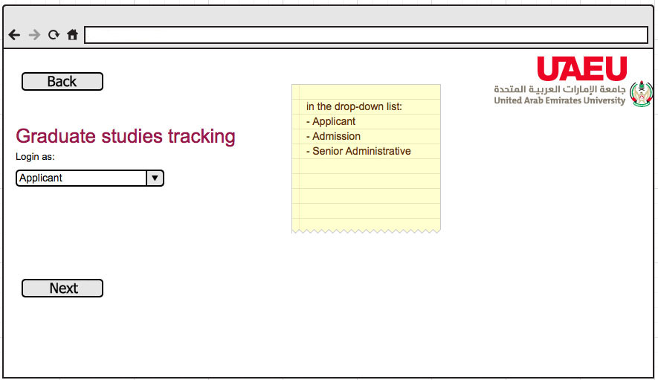

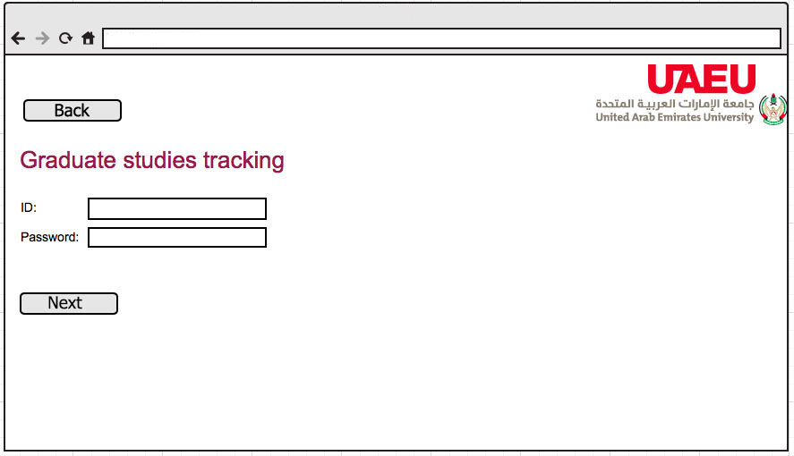

* Applicants

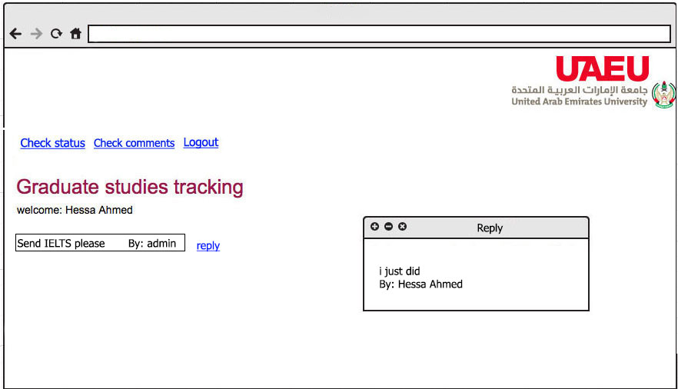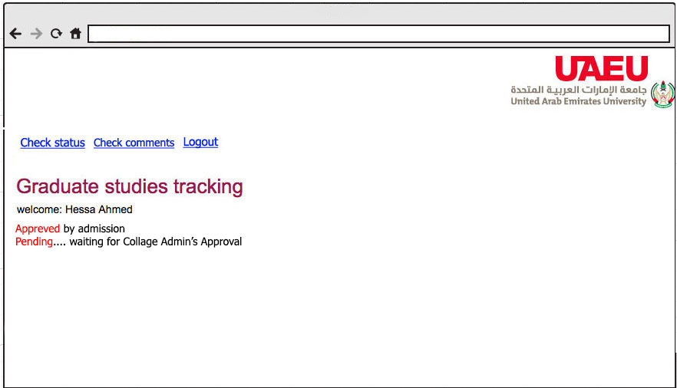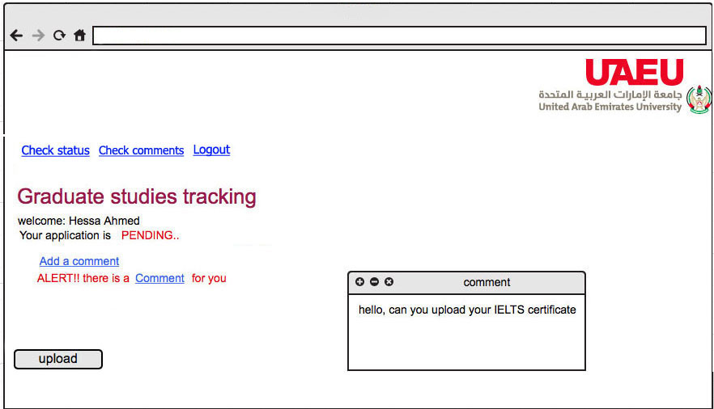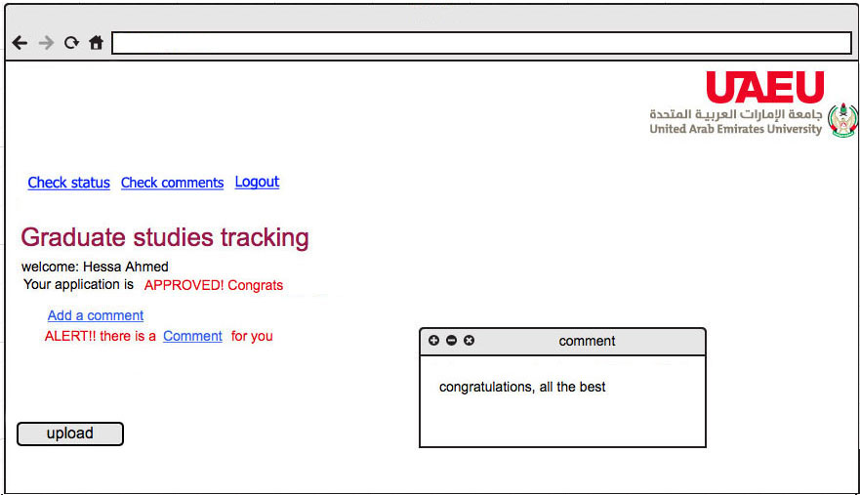

Admissions / Senior Admin:

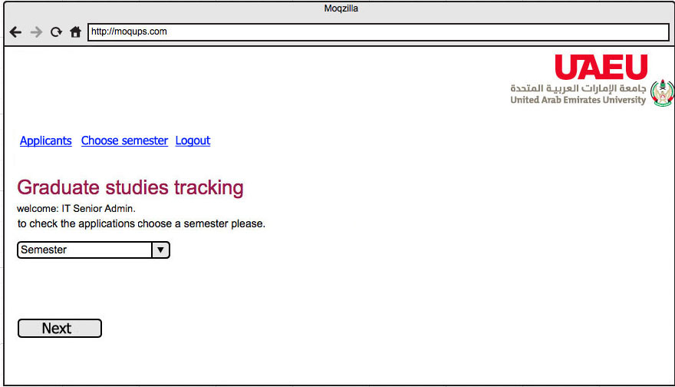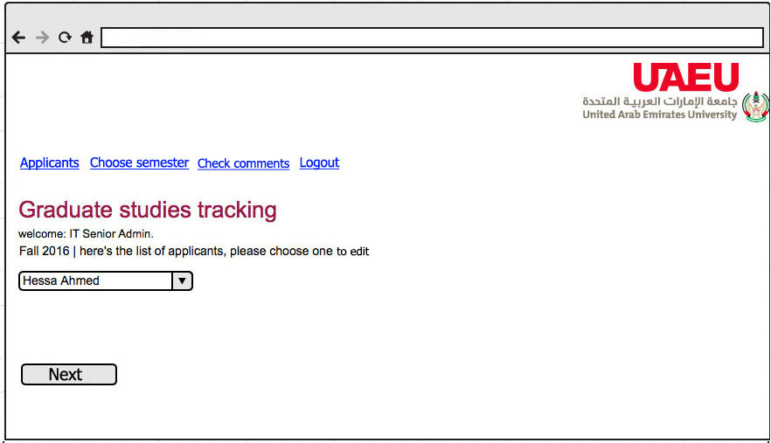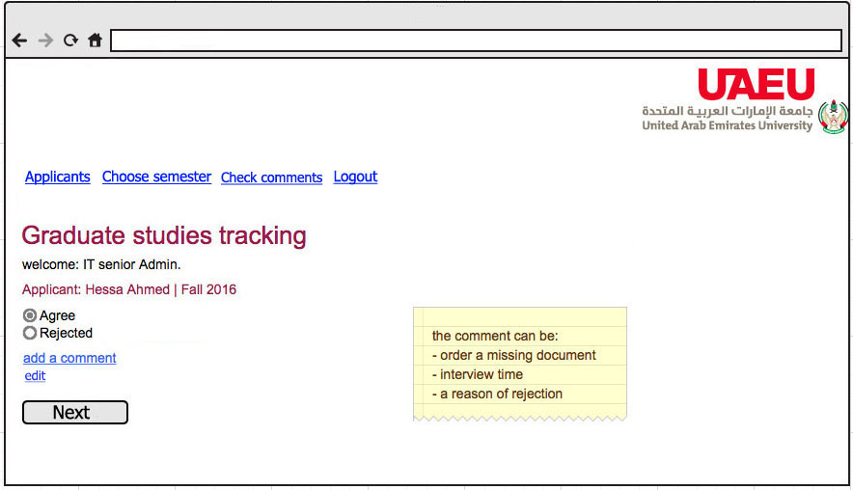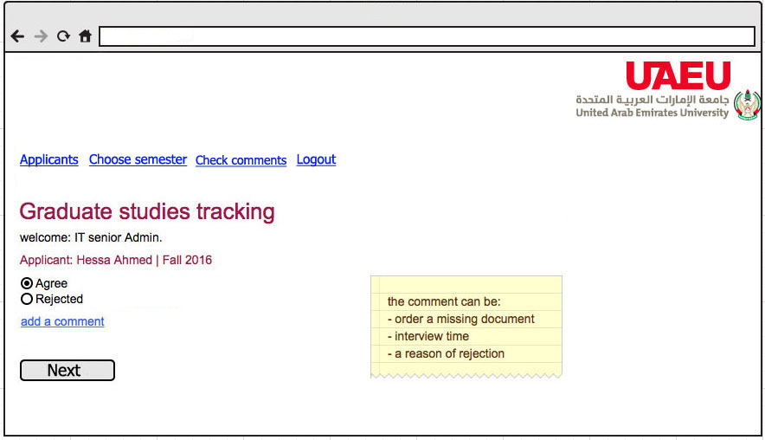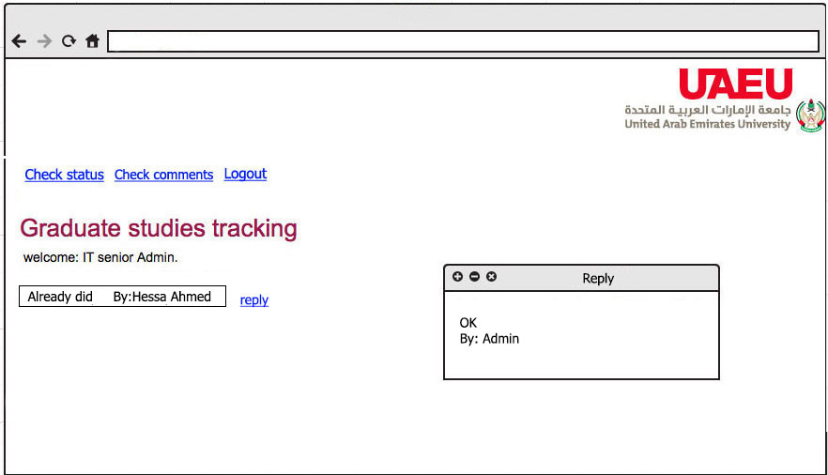

# Appendix 2: functional requirement

**Name:**Login

**Description:**The access tothe system

**Actors:**Applicant, employee, database

**Precondition:**employee users have an account and the system is up and running.

**Post condition:**User is logged into the system and ready to use the system services.

**Main flow events:**

1. User enters his username (ID).
2. User enters his password.
3. Database system validate the username and password.
4. User click login
5. <include> Select Semester.

**Alternatives:**

1. New Applicant user (MF1)
   1. <Extend> Register
   2. Return to step 1
2. Invalid user (MF3)
   1. An “Invalid user ID” message is displayed.
   2. Return to step 1.
3. Invalid password (MF3)
   1. An “Invalid user password” message is displayed.
   2. Return to step 1.

**Name:**Register

**Description:**Applicant user creation

**Actors:**Applicant, database

**Precondition:** The system is up and running.

**Post condition:**User is registered and able to logged into the system.

**Main flow events:**

1. User fills the fields.
2. <include> upload.
3. Database system validate the required data.
4. User click register.

**Alternatives:**

1. Invalid data entered (MF3)
   1. “Invalid type of data” messages is displayed beside each field.
   2. Return to step 1.
2. Missing required field (MF3)
   1. “* This is a required field” messages is displayed beside each field.
   2. Return to step 1.

**Name:**Select semester

**Description:**Semester selection

**Actors:**Applicant, employee, database

**Precondition:** User is logged into the system.

**Post condition:**User is selected the required semester.

**Main flow events:**

1. User select the required semester from the drop down menu.
2. User click continue.

**Alternatives:**

1. Invalid selection (MF1)
   1. A “select the semester” message is displayed.
   2. Return to step 1.

**Name:**Upload

**Description:**Upload required documents.

**Actors:**Applicant, database

**Precondition:** User is logged into the system.

**Post condition:**

1. User upload the appropriate files.
2. Files is saved in the database system.

**Main flow events:**

1. User enters the file to be upload.
2. The system validates the file in term of size and type permissible jpg and PDF.
3. The files are saved in the database system.

**Alternatives:**

1. Invalid file (MF2)
   1. A “choose a correct file” message is displayed.
   2. Return to step 1.
2. Database is disconnected (MF3)
   1. A “Database is disconnected” message is displayed.
   2. Return to step 1.

**Name:**Check status

**Description:**tracking the application status.

**Actors:**Applicant, database

**Precondition:** User is logged into the system.

**Post condition:**The application status is displayed to the user.

**Main flow events:**

1. User click check status.
2. Appropriate comment is displayed.
3. <include> Comment.

**Alternatives: -**

**Name:**Select college

**Description:**Filtering the applications among colleges

**Actors:**Employee (admission), database

**Precondition:** User is logged into the system.

**Post condition:**selected college’s application is displayed.

**Main flow events:**

1. User select a college name from the menu.
2. User click continue.

**Alternatives: -**

1. Invalid selection (MF1)
   1. A “select the college” message is displayed.
   2. Return to step 1.

**Name:**Select applicant

**Description:**Display all application.

**Actors:**Employee, database

**Precondition:** User is logged into the system.

**Post condition:**All application is displayed.

**Main flow events:**

1. User select particular applicant.
2. <include> View application
3. <include> Choose status

**Alternatives: -**

1. Invalid selection (MF1)
   1. A “select an applicant” message is displayed.
   2. Return to step 1.

**Name:**View Application

**Description:**Open all information about the applicant

**Actors:**employee, database

**Precondition:** User is logged into the system.

**Post condition:**application and documents are opened.

**Main flow events:**

1. User click view application.
2. The application form is viewed to the user.

**Alternatives: -**

1. Add Comment
   1. <Extend> Comment
   2. Return to step 1.
2. corrupted file (MF1)
   1. A “cannot open the file” message is displayed.
   2. Return to step 1.
3. The file is missing (MF1)
   1. A “The file is not found” message is displayed.
   2. Return to step 1.

**Name:**Choose status

**Description:**Updating the status of the application.

**Actors:**Employee, database.

**Precondition:** User is logged into the system and select an applicant.

**Post condition:**A status is updated.

**Main flow events:**

1. User click on one of the statuses.
   1. Approved.
   2. Rejected.
   3. Not complete.
2. The status is updated.

**Alternatives: -**

1. Rejected reason (MF1b)
   1. <Extend> Comment.
   2. Return to step 2.
2. Not complete reason (MF1b)
   1. <Extend> Comment.
   2. Return to step 2.
3. Database is disconnected (MF2)
   1. A “Database is disconnected” message is displayed.
   2. Return to step 1.

**Name:**Comment

**Description:**Writing a comments about the application.

**Actors:**Applicant, employee, database.

**Precondition:**

* User is logged into the system
* Applicant check status
* Employee select applicant

**Post condition:**Comment is posted.

**Main flow events:**

1. User check/choose status
2. User write a comment about the status.
3. User click Send.
4. <include> Alert.

**Alternatives: -**

1. Reply to previous comment (MF1).
   1. <Extend> Reply.
   2. Return to step 2.
2. Applicant User upload missing files (MF2).
   1. <Extend> Upload.
   2. Return to step 2
3. Database is disconnected (MF3)
   1. A “Database is disconnected” message is displayed.
   2. Return to step 2.

**Name:**Reply

**Description:**Reply to previous existing comment.

**Actors:**Applicant, employee, database.

**Precondition:**

* User is logged into the system
* Applicant check status and there is a comment.
* Employee select applicant and there is a comment.

**Post condition:**reply comment is posted.

**Main flow events:**

1. User receive alert about a comment
2. User view the comment
3. User reply to comment.
4. User click Send.

**Alternatives: -**

1. Applicant User upload missing files (MF3).
   1. <Extend> Upload.
   2. Return to step 3
2. Database is disconnected (MF4)
   1. A “Database is disconnected” message is displayed.
   2. Return to step 2.

**Name:**Alert

**Description:**Notification about a comment posted.

**Actors:**Applicant, employee, database.

**Precondition:**

* User write a comment.
* User reply to comment.

**Post condition:**Alert is sent.

**Main flow events:**

1. User send an alert E-mail to a comment’s receiver.
2. Alert E-mail is sent.

**Alternatives: -**

1. Upload missing files (MF3).
   1. <Extend> Upload.
   2. Return to step 3

**Name:**Logout

**Description:**exit from the system.

**Actors:**Applicant, employee, database.

**Precondition:** User is logged into the system.

**Post condition:**User is logged out from the system.

**Main flow events:**

1. User click logout.
2. User is logged out from the system.

**Alternatives: -**

1. Not logged in (MF1)
   1. A “you are not logged in” message is displayed.
   2. Return to step 1.